Grade | Content Areas Being Integrated
4 | Music/Mathematics

 | Arts Discipline | Other Content Area
Standards  Addressed in the Integrated Lesson/Activity | 1.3 Read, write, and perform rhythmic notation, including sixteenth notes, dotted notes, and syncopation (e.g., eighth/quarter/eighth note and eighth-rest/quarter/eighth note).  2.3 Compose and improvise simple rhythmic and melodic patterns on classroom instruments. | MP 4. Model with mathematics.  MP 7. Look for and make use of structure.  MP 8. Look for and express regularity in repeated reasoning. (This occurs as we look at a time signature other than a 4/4.)  3.NF.1. Understand a fraction 1/b as the quantity formed by 1 part when a whole is partitioned into b equal parts; understand a fraction a/b as the quantity formed by a parts of size 1/b. (This is a 3rd grade standard, but is an important understanding to be reviewed. The focus of this lesson is in the Math Practices (MP) which are prominent in all grades. I would use this lesson as an introduction to fractions in the fourth grade.)
Student Objectives in Each Discipline | The students will be able to read, write, and perform rhythmic notation. | Students will understand how music rhythm is structured using fractions, clearly communicate this understanding, and use fractions to model rhythms.

Integrated Student Objective | What is the objective of the integrated activity? Look at connections being made between the two content areas.  The students will be able to read, write, and perform rhythmic notation using fraction concepts.
Essential Question | What is the question you want the students to be able to answer at the end of this lesson?  How is music accurately modeled with mathematics? How are fractions used to divide abstract things like time and music?

Materials/Resources
Construction Paper – red, blue, yellow, white. One set of sheets per small group plus one set for demonstration.
Whiteboard
Whiteboard markers
Elmo
Sample music in 4/4 time (common time) 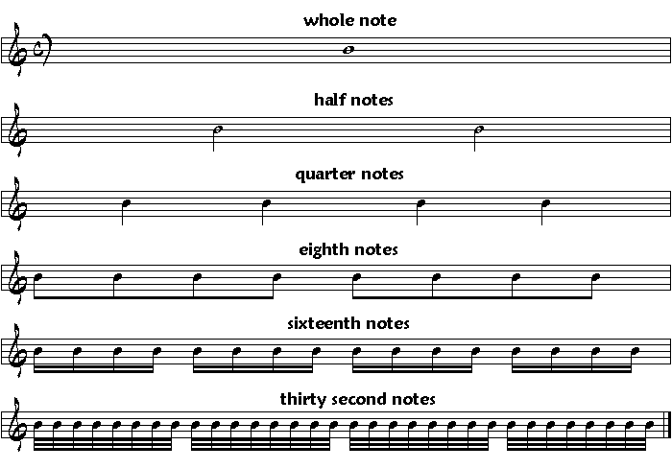 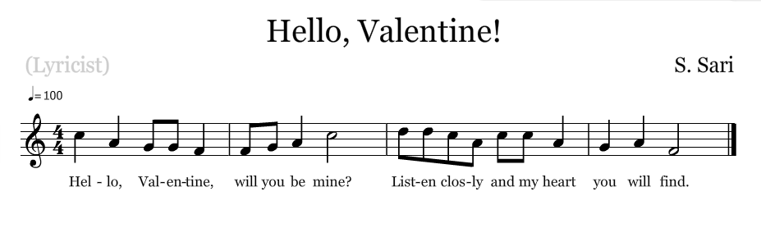
Sample music in ¾ time (for extension)
Copies of paper with blank staffs
Pencils
Any percussion instrument available (clapping hands will do)
Chart and markers to record new vocabulary

Lesson/Activity Description
Set up:
- Discuss definition of rhythm
- Discuss definition of beat
- Put students into groups of 3, 4, or 5
- Make rhythm cards – whole red sheet (clap lasts for 4 beats), tear blue sheet into two equal parts (cut in half while holding paper horizontally or landscape) blue sheets are half the red, so they only last for 2 beats. Yellow sheets cut in fourths, and white sheets in eighths.
- As a class, clap out what a red, blue, blue, yellow, yellow, yellow, yellow, and white (x8) would sound like.
- Practice different rhythms by moving the cards around (blue, yellow, yellow, blue, red) whole group, then small groups. Have groups share out their rhythms while others try to match the rhythm cards to what they hear.
During:
- Have students draw the whole note on the red, half note on the blue, etc. asking them why they think the notes are named like this and encouraging them to predict the names of the yellow and white. (quarter and eighth notes)
- Practice clapping (or tapping-whatever) a rhythm with the newly marked rhythm cards.
- Show samples of 4/4 music.
- Ask students to try and figure out what the 4/4 represents.
- Explain measure
- As a class, return to the rhythm cards and notate an agreed upon rhythm onto a black staff using the ELMO. Practice reading the music and playing
- Introduce and use the repeat symbol on the staff
- Have groups come up with a rhythm they like using the rhythm cards.
- Once they agree, notate their rhythm on the blank staffs
- Have three groups bring their papers up to display
- Either have groups try to play what other groups have written or have groups play their own and the audience guesses which staff is being played.
Close / reflect:
- How is math used to divide abstract things like time and music?

